Chapter 9, Solution 2.

- amplitude = 15 A

-  = 25 = 78.54 rad/s

- f = 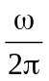 = 12.5Hz

- I_{s} = 1525 A
I_{s}(2 ms) = 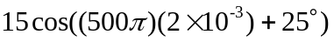
= 15 cos( + 25) = 15 cos(205)
= –13.595 A

